Figures, time, dates, addresses …

Pronunciation of the alphabet

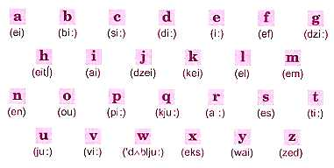

Figures and Numbers
. | . | 10 | ten / tenth | 20 |  | twenty | . | .
1 | one / first | 11 | eleven | 21 |  | twenty-one | . | .
2 | two / second | 12 | twelve | 22 |  | twenty-two | 20 | twenty / twentieth
3 | three / third | 13 | thirteen | 23 |  | twenty-three | 30 | thirty / thirtieth
4 | four / fourth | 14 | fourteen | 24 |  | twenty-four | 40 | forty / fortieth
5 | five / fifth | 15 | fifteen | 25 |  | twenty-five | 50 | fifty / fiftieth
6 | six / sixth | 16 | sixteen | 26 |  | twenty-six | 60 | sixty
7 | seven / seventh | 17 | seventeen | 27 |  | twenty-seven | 70 | seventy
8 | eight / eighth | 18 | eighteen | 28 |  | twenty-eight | 80 | eighty
9 | nine / ninth | 19 | nineteen | 29 |  | twenty-nine | 90 | ninety
0.5 | point five | 1.9 | one point nine | 1% |  | one percent | 1-10 | one to ten
100 : one hundred |  | 101 : one hundred and one |  |  |  |  | 1000 : .one thousand
1,000,000 one million (m) |  |  |  |  | 1,000,000,000 one billion (b, bn)

Days Months Seasons
1 Monday | 1 January | Spring
2 Tuesday | 2 February | Summer
3 Wednesday | 3 March | Autumn (UK) / Fall (US)
4 Thursday | 4 April | Winter
5 Friday | 5 May | .
6 Saturday | 6 June | .
7 Sunday | 7 July | .
. | 8 August | .
. | 9 September | .
. | 10 October | .
. | 11 November | .
. | 12 December | ..

What time is it?

24 hours | 00:00 | 12:00 | 01:00 | 13:00
12 hours | 12.00 a.m. | 12.p.m. | 1.00 a.m. | 1.00 p.m.
written | midnight | midday / noon | one o’clock in the morning | one o’clock in the afternoon

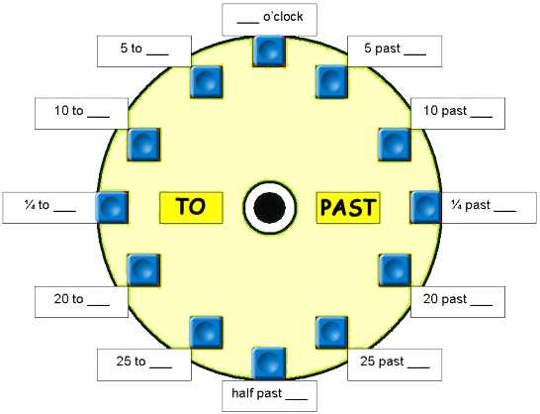

or: one fifteen, one thirty, one forty-five, ten twenty-five, eleven twenty, six fifty …
Now tell the time !

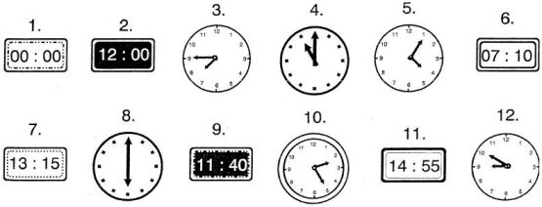

Dates
9/11/2001 (US)  11/9/2001 (UK) | the eleventh of September two thousand (and) one | September the eleventh two thousand and one
01/01/2006  01 Jan 2006  Jan 01 2006 | the first of January two thousand (and) six | January the first two thousand (and) six
31/12/2005 | the thirty-first of December two thousand (and) five  new year’s eve | December the thirty-first two thousand (and) five
in the 1990’s | in the nineteen nineties
the 60’s | the sixties
Jan ‘04 | January two thousand and four

Telephone and Internet addresses
01 0845 166 7111: O one O eight four five one double six seven one double one

http://www.washington-post.com/index

: colon / slash // double slash - dash .dot

Units and abbreviations
£ : (sterling) pound $ : dollar A$ : Australian dollar (AUD)
N : north E : east W : west S : south
17” screen : a seventeen inch screen 5’ : five feet (about 1.5m)
£ 6.99 inc VAT/month : six pounds ninety-nine (cents) including value added tax per month
Ltd : limited &Co : and company Inc : incorporated
Mr : [miste] Mrs: [misiz] Miss: [mis] Ms [miz]

figures, numbers, dates, addresses …
Name : Form : Date :
Transcrivez les expressions suivantes en toutes lettres (telles qu’elles doivent être prononcées) dans la seconde colonne
Only £999
a 15.1" screen
Phone : 0877 833 012
2.5bn people
from 8am to 6pm
01:00
$9.89
Dec 1 2000
http://www.al-ltd.com/index
Days 2-7
$5 / week
10% / year
Feb 3 & 10
05/01/06
14 :30
Sat & Sun only
dell-computers.co.uk/deal
24 hrs
01 882 737 555
open 24/24 & 7/7
£10m-£15m
her 41st birthday
£2.2bn ($3.9bn)
London SW1

Correction / figures and abbreviations
- Only nine hundred ninety-nine pounds (sterling)
- A fifteen point one-inch screen
- phone O eight double seven eight double three O one two
- two point five billion people
- from 8 in the morning to 6 in the evening
- one o’clock / one
- nine dollars eighty-nine (cents)
- the first of December two thousand
December the first two thousand
- http colon double slash www dot AL dash PST dot COM slash index
- from day two to seven
from the second to the seventh day
- five dollars per week
five dollars a week
- ten percent a year
ten percent per year
- the third and the tenth of February
February the third and the tenth
- the fifth of January two thousand (and) six
January the fifth two thousand six
May the first two thousand six
the first of May two thousand six
- half past two in the afternoon
two thirty pm
- on Saturdays and Sundays only
- DELL dash COMPUTERS dot CO dot UK slash DEAL
- twenty-four hours
- one double eight two seven three seven five double five
- open twenty-four hours a day and seven days a week
- ten to fifteen million pounds
- her forty-first birthday
- two point two billion pounds or three point nine billion dollars
- London south west one

figures, numbers, dates, addresses …/ TEST
Name : Form : Date :
Transcrivez les expressions suivantes en toutes lettres (telles qu’elles doivent être prononcées) dans la seconde colonne
Only £999.99
a 17.5" screen
Phone : 0877 833 012
4.5bn people
7am - 5pm
$9.89
Dec 1 2005
http://www.al-ltd.com/index
Days 2-7
$5 / week
10% / year
Feb 3 & 10
05/01/06
15 :30
Sat & Sun only
01 882 737 555
open 24/24 & 7/7
her 41st birthday
£2.2bn ($3.9bn)
London SW1

a |  | b |  | c |  | d |  | e |  | f |  | g
[ei] |  | [bi:] |  | [si:] |  | [di:] |  | [i:] |  | [ef] |  | [dzi:]
 | h |  | i |  | j |  | k |  | l |  | m
 | [eit.] |  | [ai] |  | [dzei] |  | [kei] |  | [el] |  | [em]
n |  | o |  | p |  | q |  | r |  | s |  | t
[en] |  | [ou] |  | [pi:] |  | [kju:] |  | (a:] |  | [es] |  | [ti:]
 | u |  | v |  | w |  | x |  | y |  | z
 | [ju:] |  | [i:] |  | [d..blju:] |  | [eks] |  | [wai] |  | [zed]

